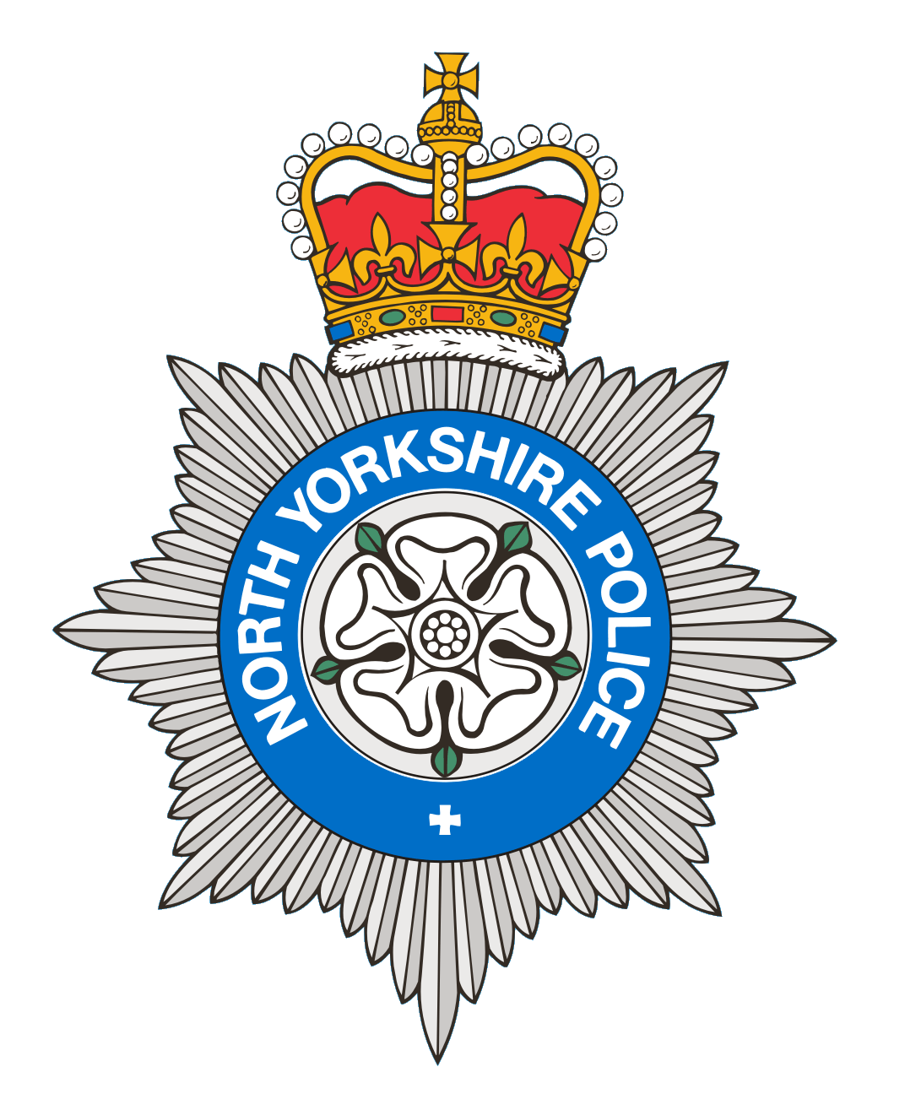
PCSO 3521 Diane Smith
Produced: 7th October 2024
Date of meeting- 10th October 2024

BROUGH WITH ST GILES
PARISH COUNCIL MEETING 10th October 2024
POLICE REPORT

20/09/2024 - 07/10/2024

Please note that under the police crime reporting system, all reports of criminal activity are recorded as crimes. However, if at a later date it is ascertained that no crime has been committed, this will not show on parish council report due to time delay.

Overall reports recorded for this period = 6
For the same period last year = 9

3 Crimes
3 x Violence
Reported crime for the same period last year = 3

0 Anti-Social Behaviour
Reports of ASB for the same period last year = 1

0 Road Safety
Other reports for the same period last year= 1

3 Personal/Safety/Warning Incidents
1 Concern reports.
1 Domestic incident reports.
1 Administration report
Other reports for the same period last year = 4

North Yorkshire Police are promoting our messaging system, please sign up today to:
Community Messaging
North Yorkshire Community Messaging allows members of the public to register to receive alerts, crime notifications and community news from organisations. It is a way of maintaining contact with Neighbourhood Watch and Rural Watch groups. Neighbourhood & Rural Watch have their own database within community messaging for their members.

​You can sign up to receive alerts as a member of the public here:
https://www.northyorkshirecommunitymessaging.co.uk/

If you wish to speak to your local Neighbourhood PCSO you can send an e-mail to PCSO3521 Diane Smith diane.smith@northyorkshire.police.uk phone 101, choose option 2, and follow the prompts.

